K.KALA MINI PROJECT OF HOSPIATAL ASSOCIATED INFECTIONS DATA SET on 24.05.26
Data set choosed from data.cms.gov and dataset .googlesearch.com
HOSPITAL DATASET CSV
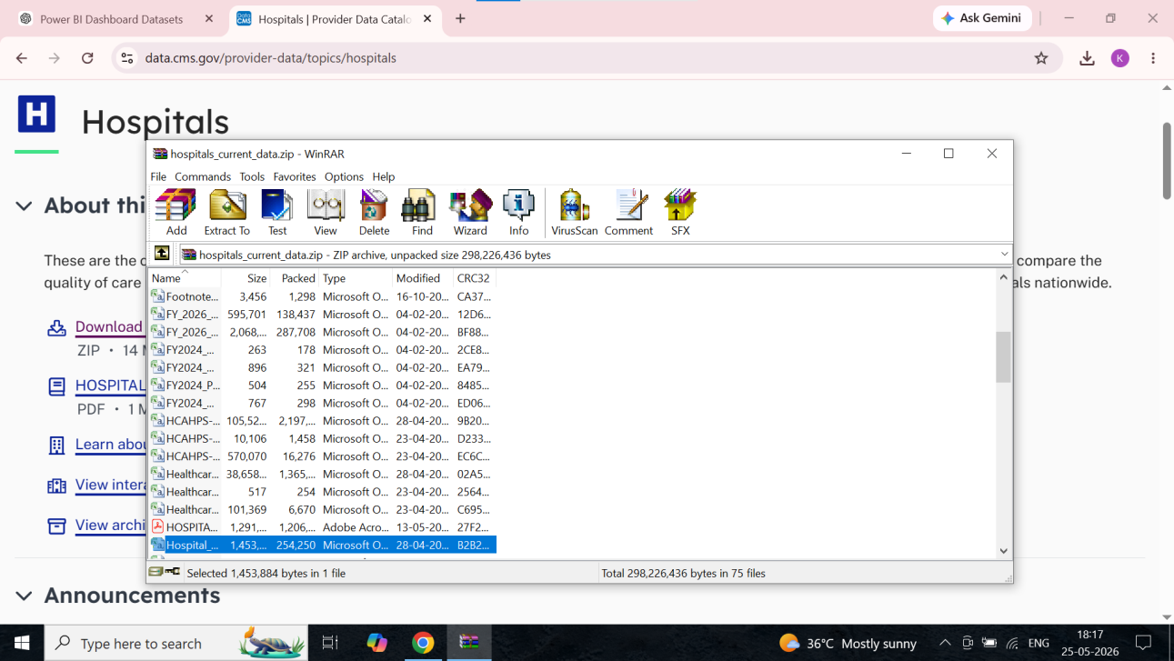
HOSPITAL ASSOCIATED INFECTIONS –HOISPITAL DATA CSV, NATIONAL DATA CSV, STATE DATA CSV

1.DATA SET CONTAIN 172513 ROWS, 15 ROWS .
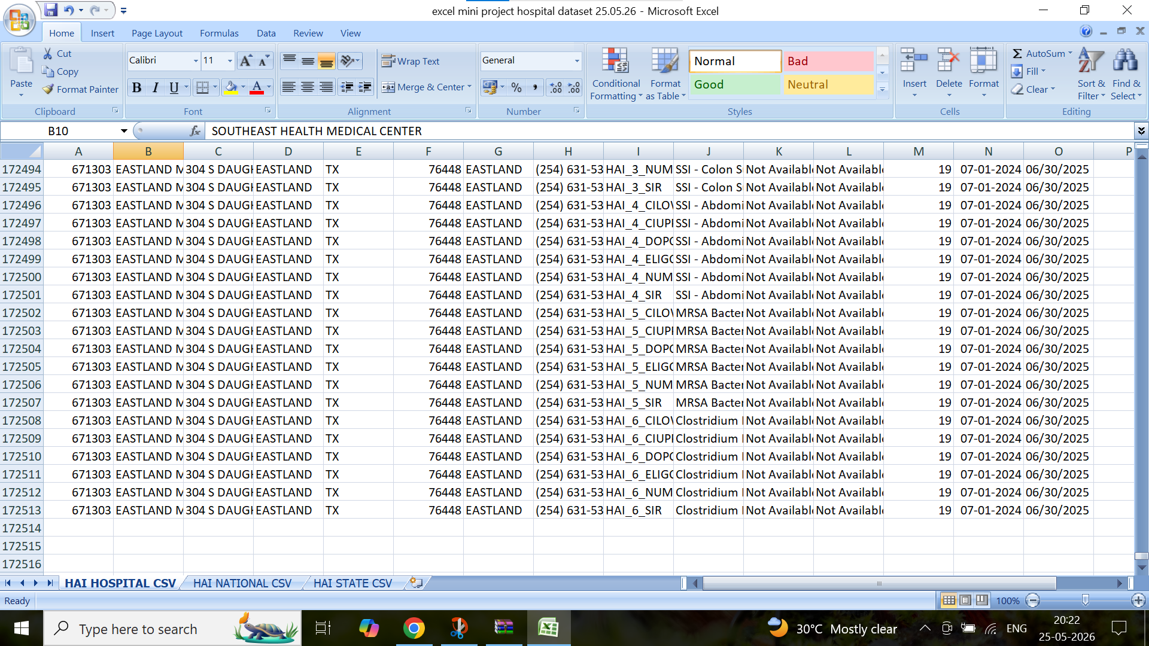
STEP 1. FACILITY NAME , STATE, MEASURE NAME – NO BLANKS , SCORE – NOT AVAILABLE -76326 RECORDS FOUND AND DELETED .
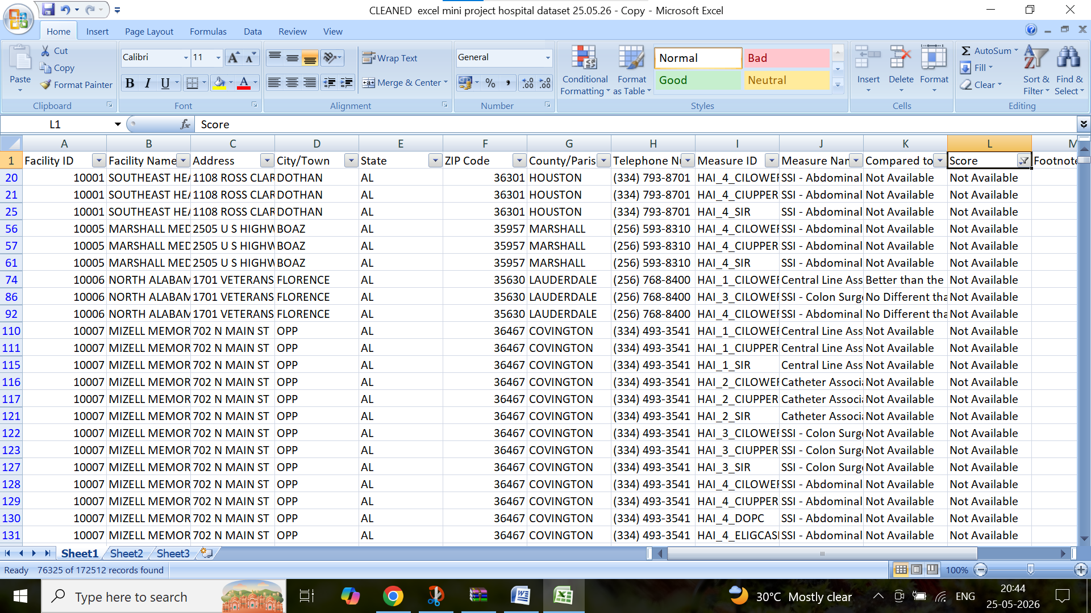

STEP 2. DELETE NOT AVAILABLE SCORE BY USING SORT , Z-A , FOUND NA DELETED . KEPT 96104 RECORDS AT PRESENT
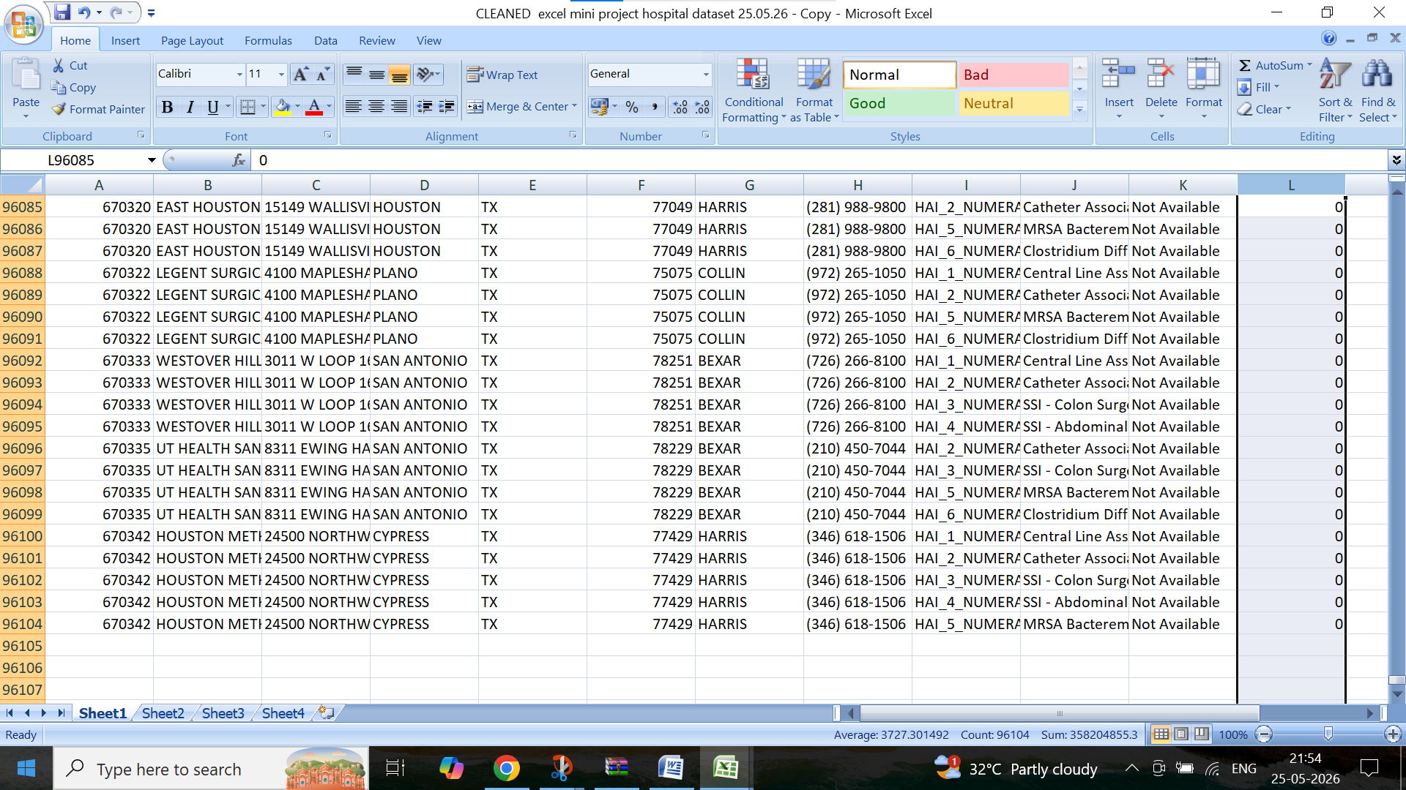
STEP 3 FACILITY ID CLEANING
1.NO BLANKS BY USING FILTER, SPACE CLEANED BY TRIM ,
2.273 + 33 NUMERIC WITH TEXT VALUE CONSIDERED AS INVALID ID N KEPT IN 4TH SHEET
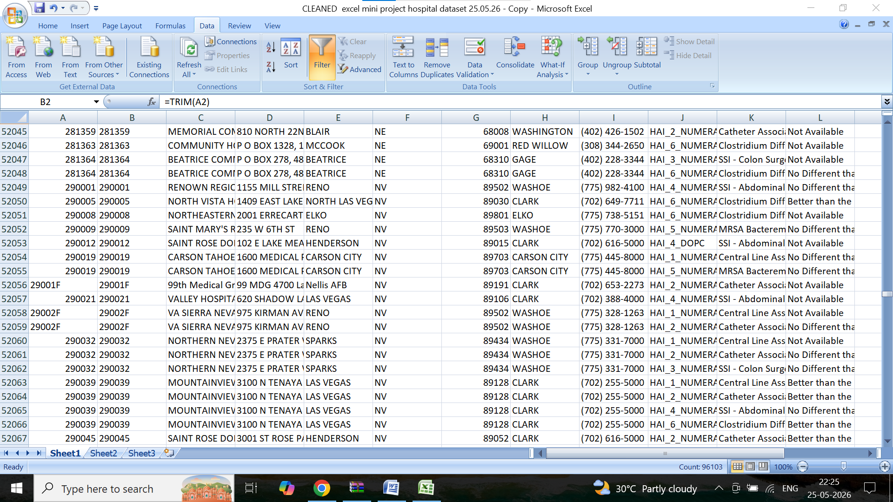

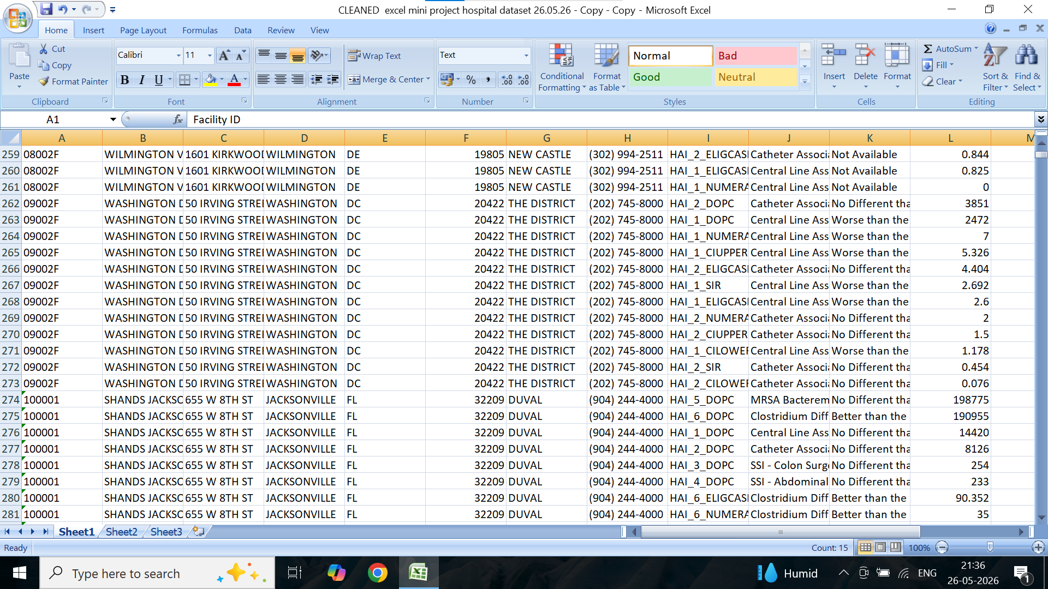

3.DUPLICATES REMOVED , 91974 FACILITY ID REMAINS UNIQUE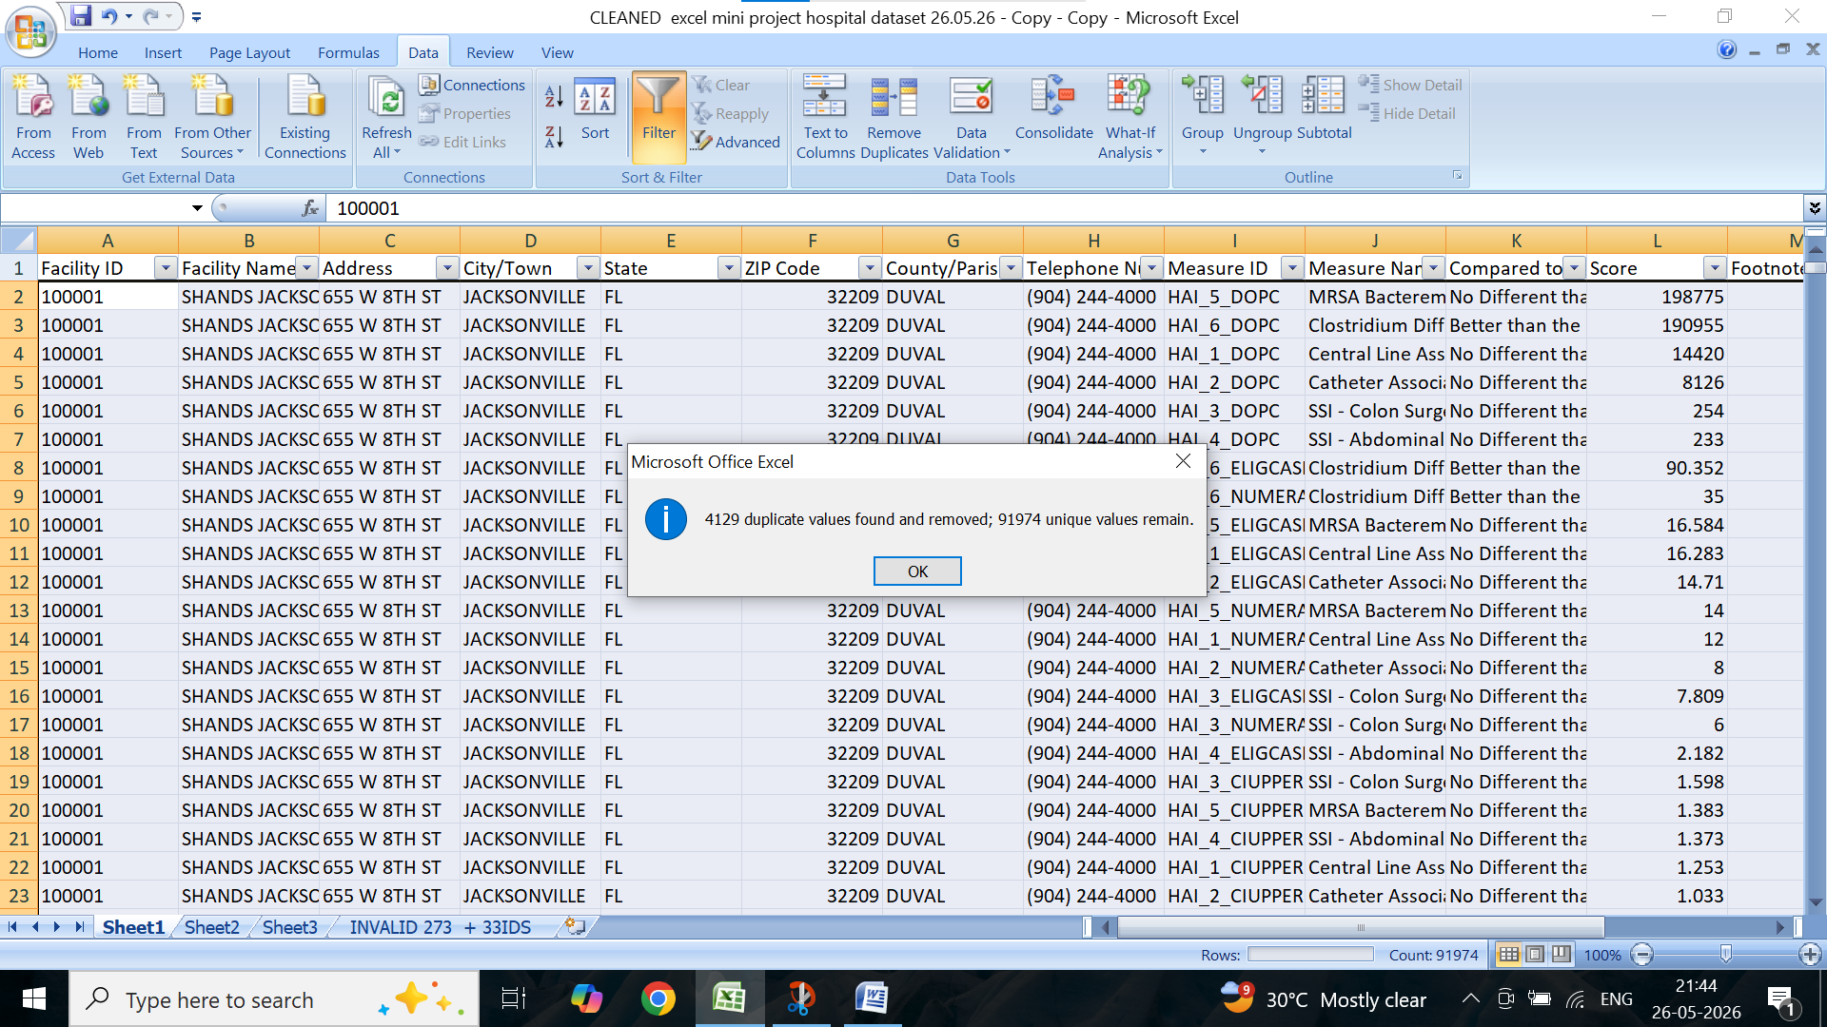

5.ZIP CODE – TRIM,ISNUMBER (VALUE),
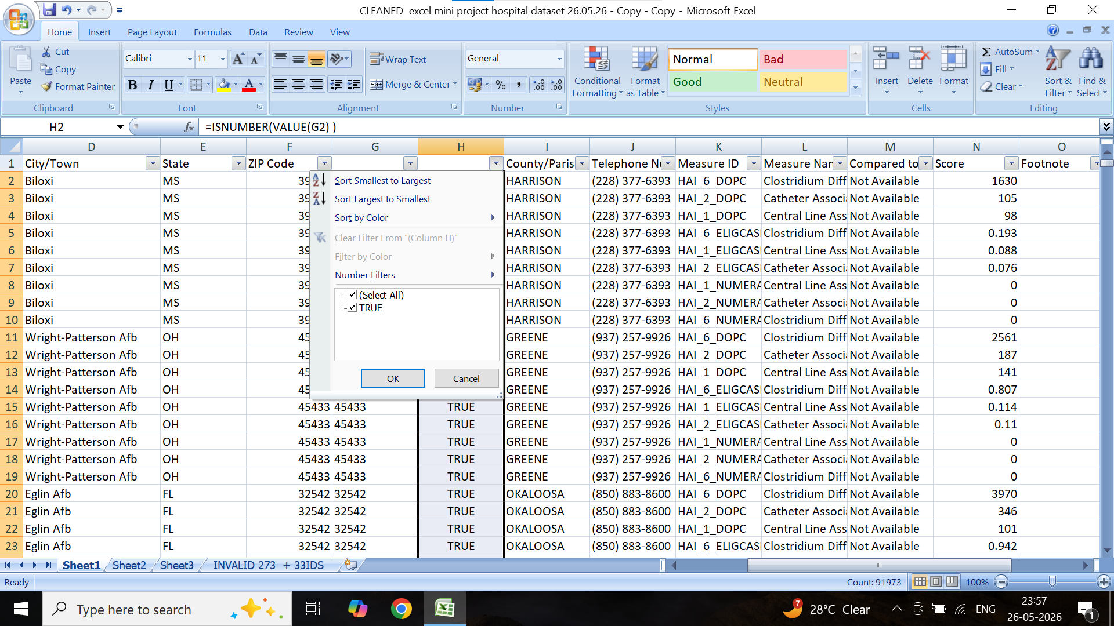

7.telephone no – substitute and left mid right formula used
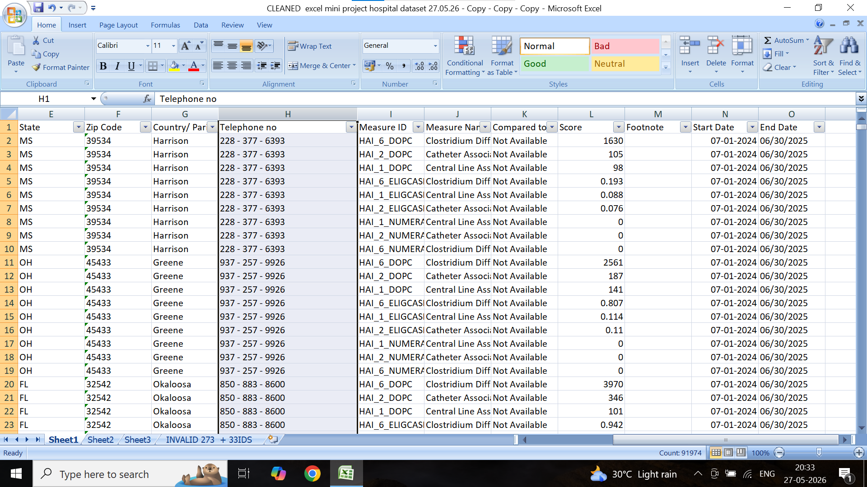

8. measure id – substitute formula
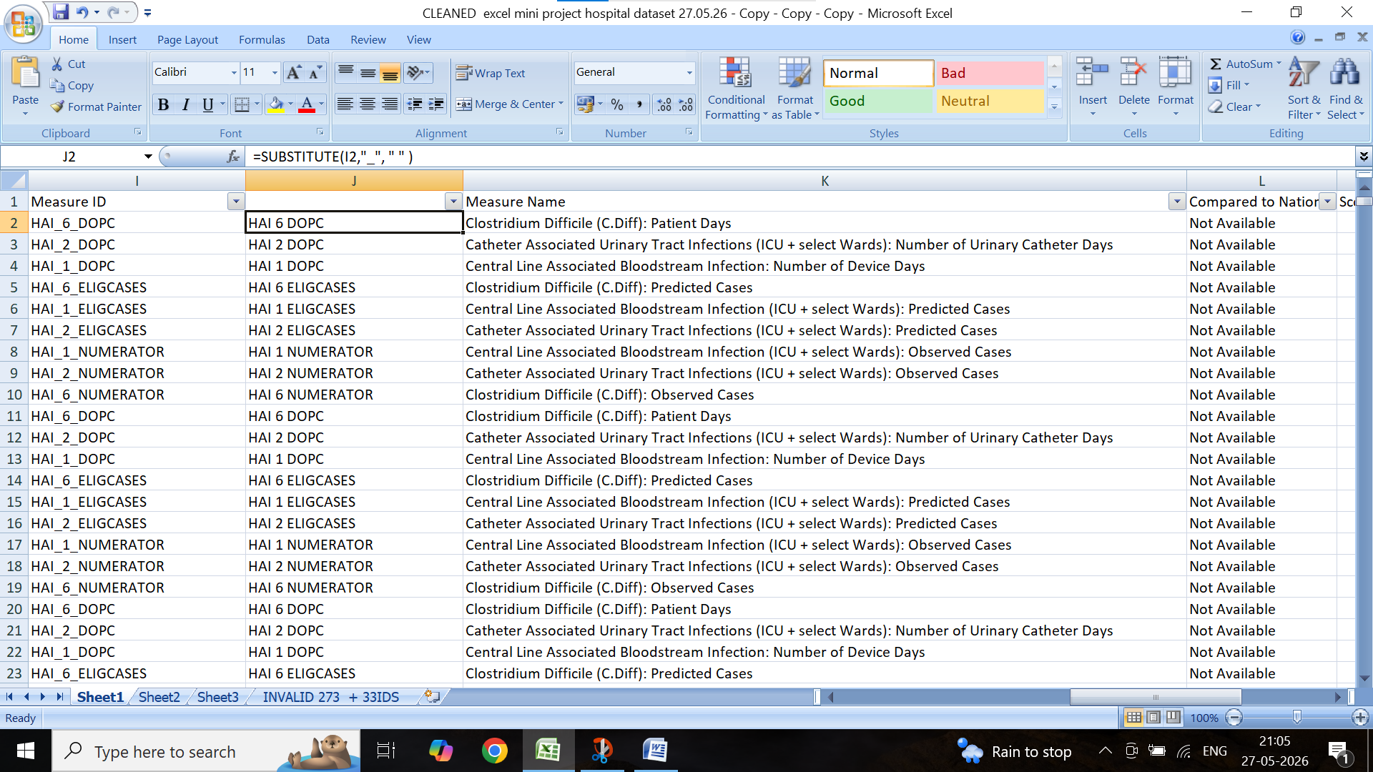
9.MEASURE NAME TO SHORT MEASURE NAME BY FIND WHAT AND REPLACE WITH USED
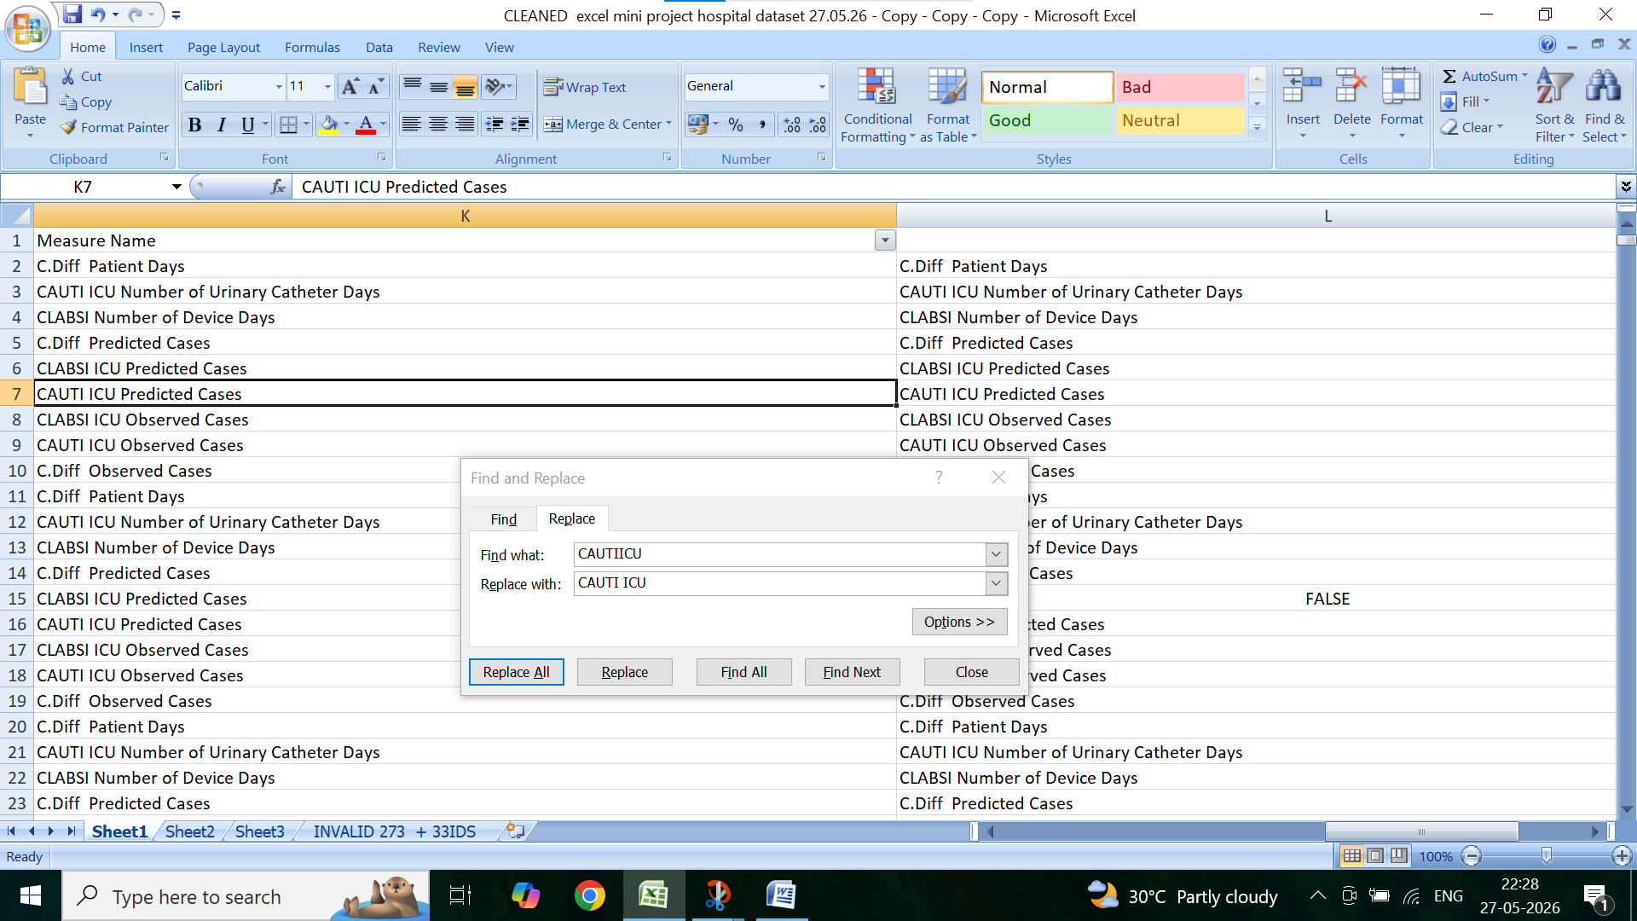

10.compared to national done by find what , and replace with
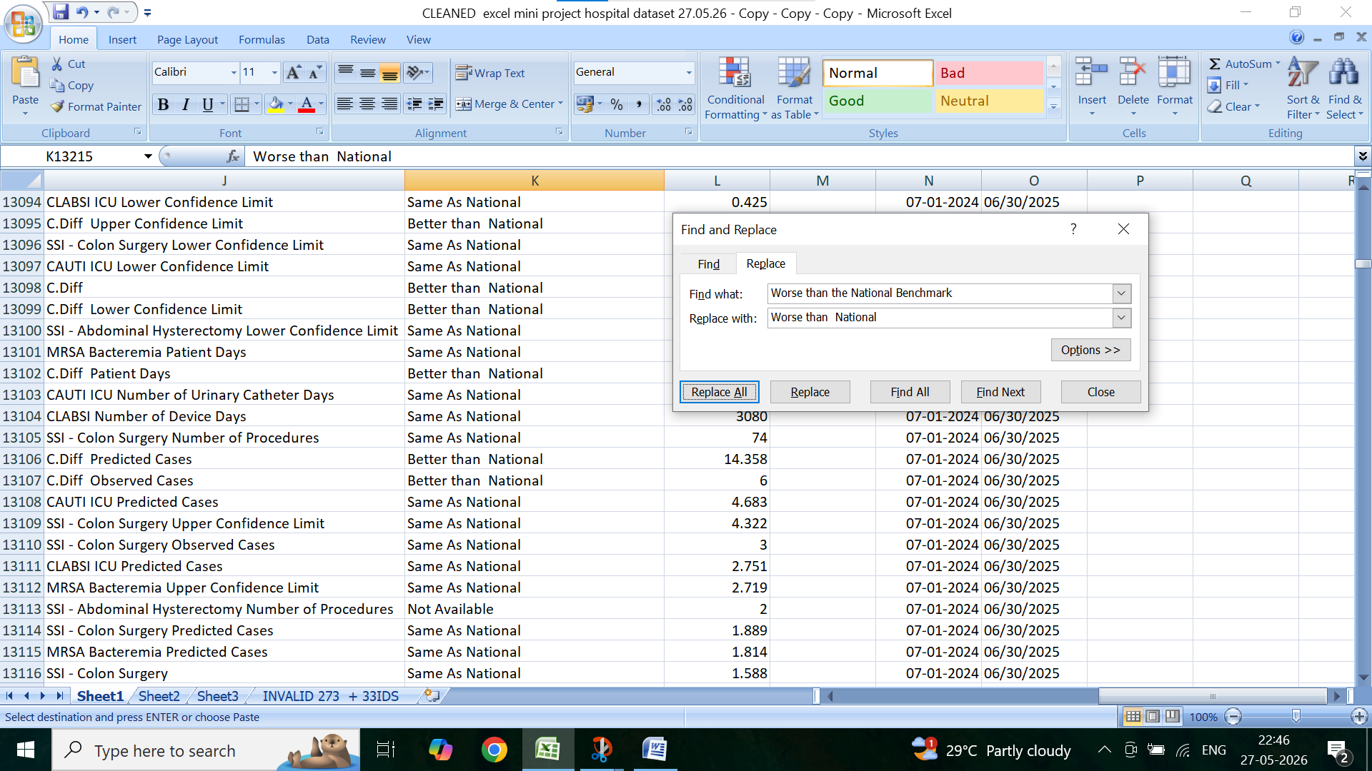
11.score corrected by trim and round formula
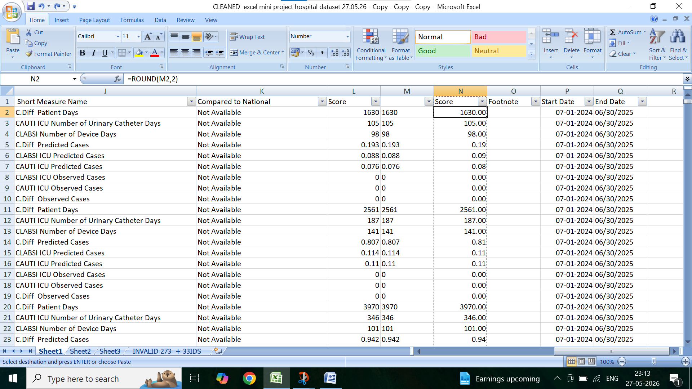

12.foot shows blanks rows kept as same blank . because standard practice in health care n helps for HAI dashboard
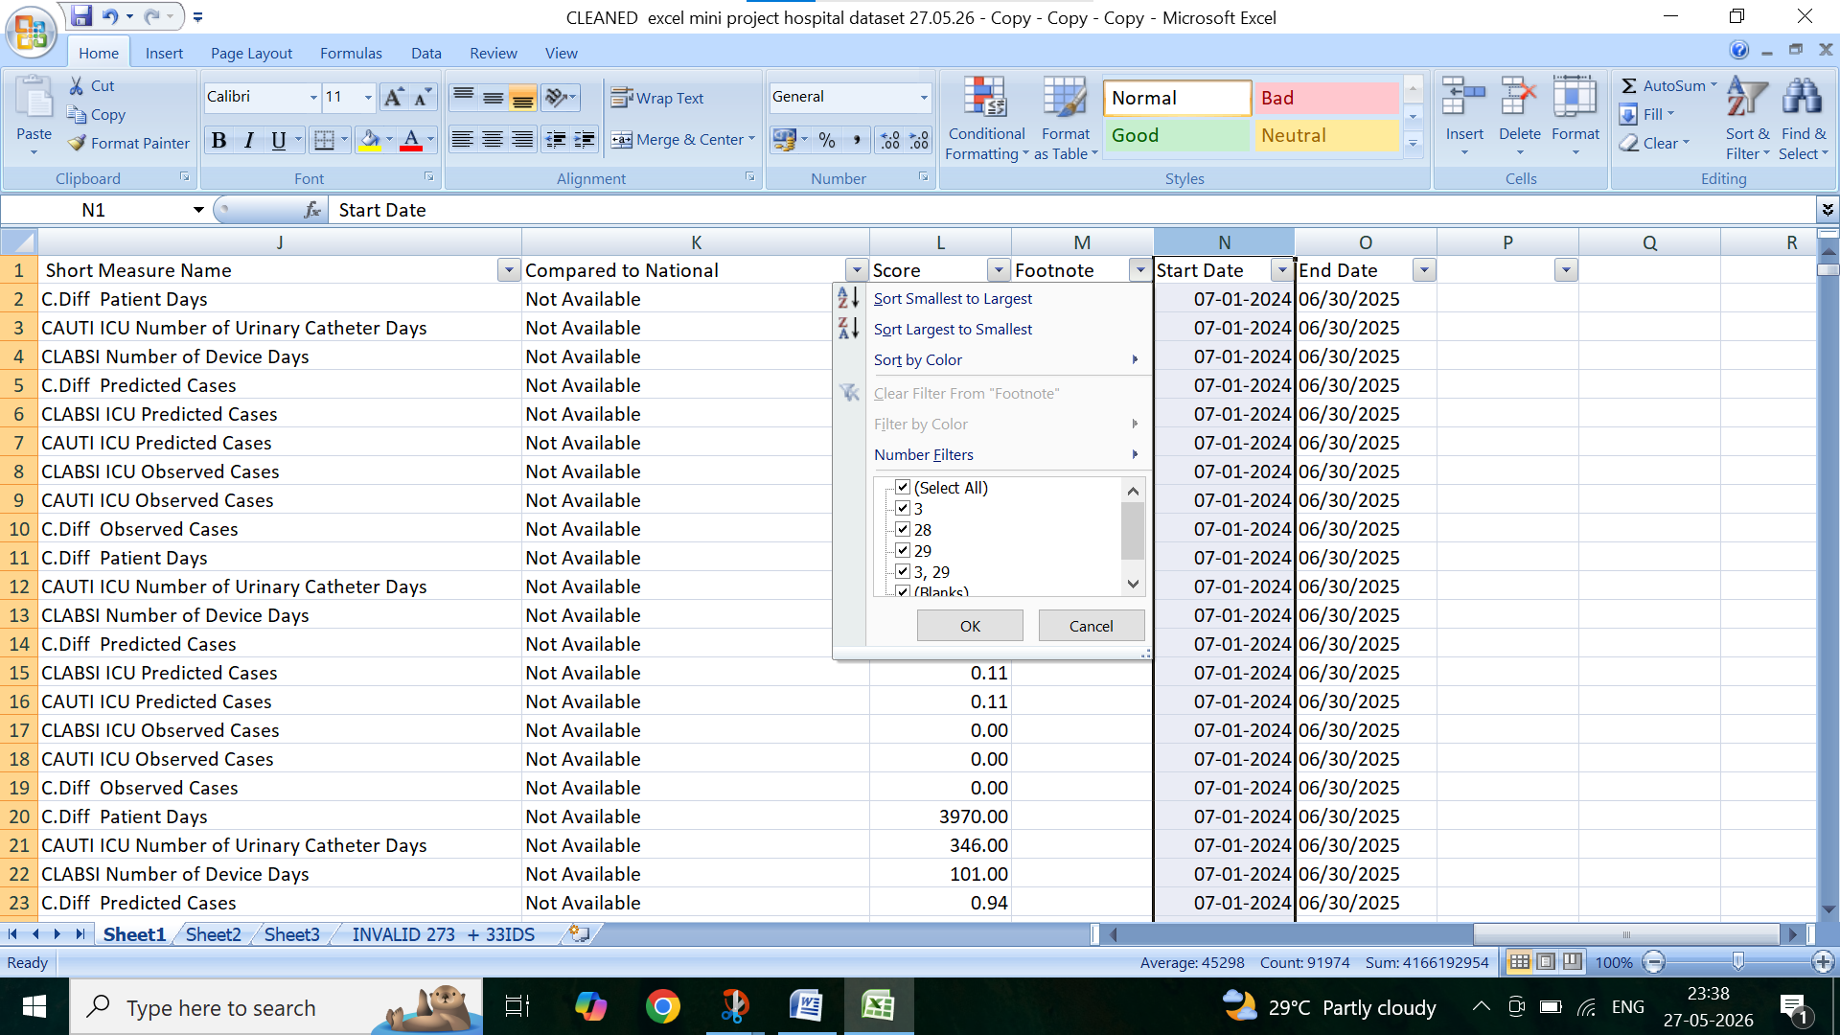

13.sart date and end date chaned ads standard format byexcel date formula and apply date format

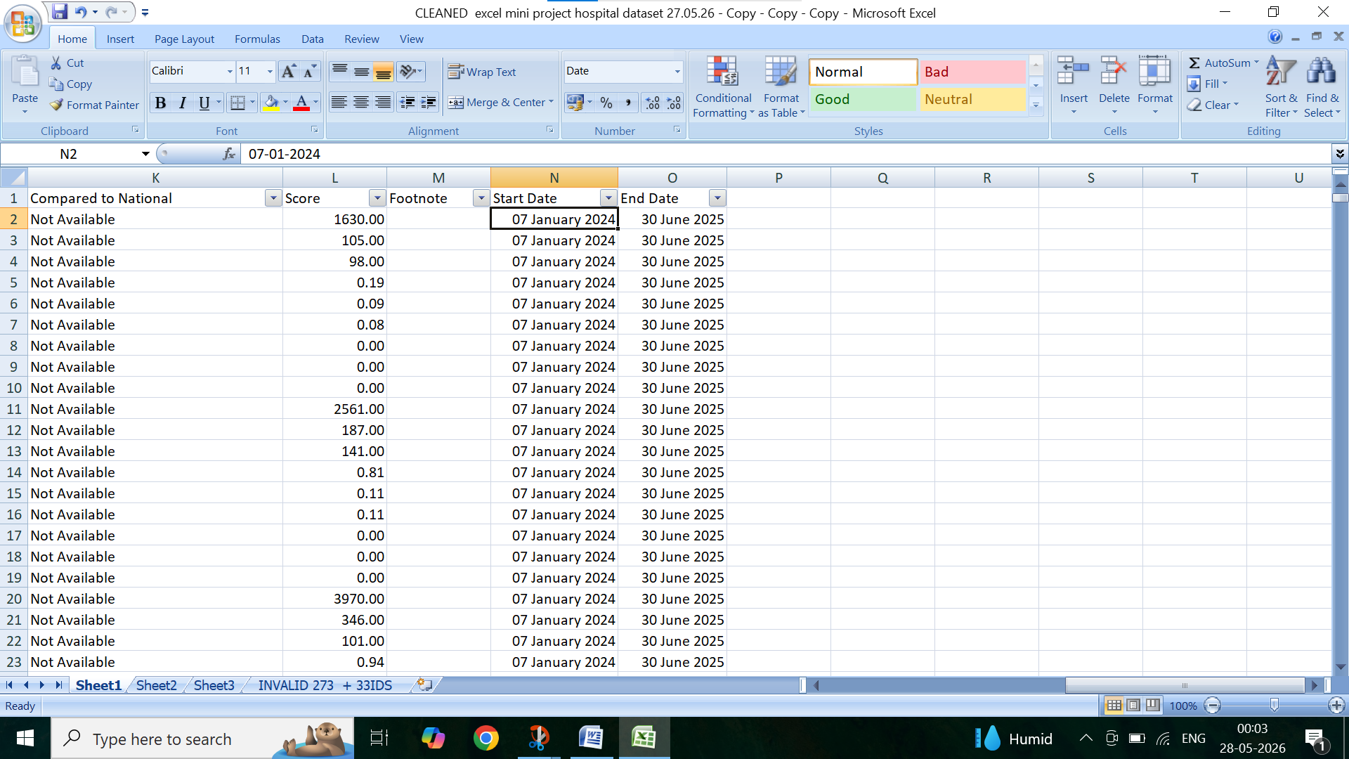

NATIONAL DATA SET CSV
1.national data csv measure id changed by using substitute formula
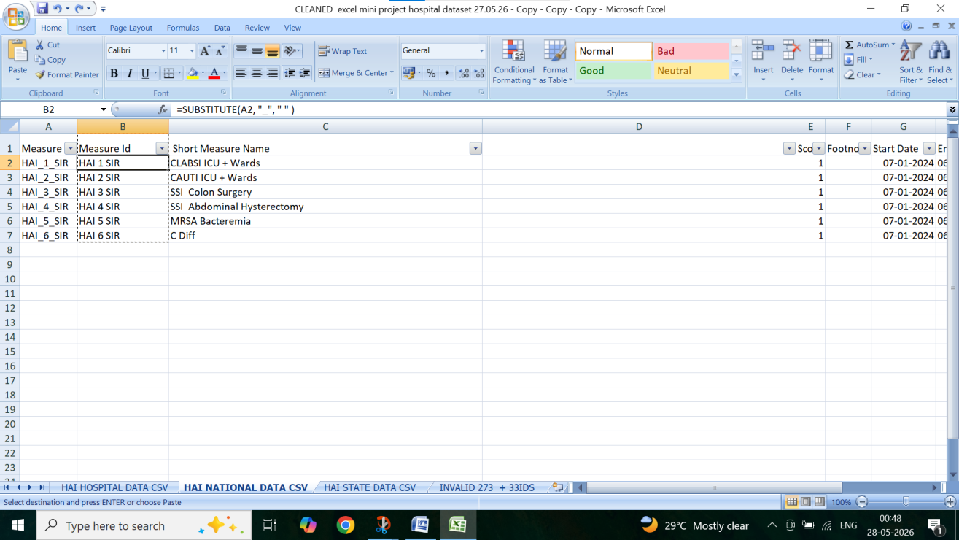

2. national data csv – measure name changed as short measure name by using find what and replacing with
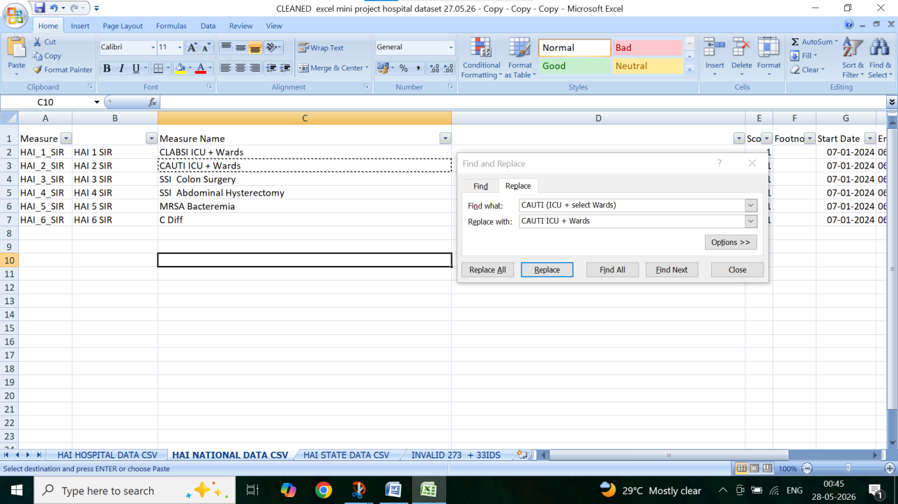
3. SCORE ONLY ONE NUMERIC VALUE , SO NO CHANGE . FOOT NOTE ONLY BLANK CHECKED BY FILTER
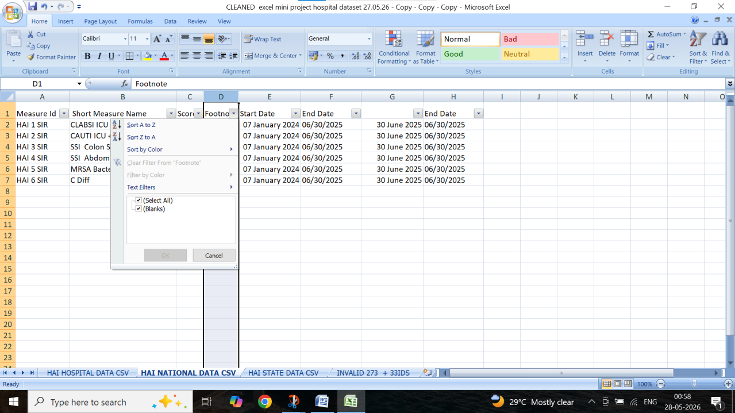
4.START DATE AND END DATE CHANGED BY NUMBER SHORT DATE , AND END DATE BY DATE , RIGHT, LEFT, MID FORMULA
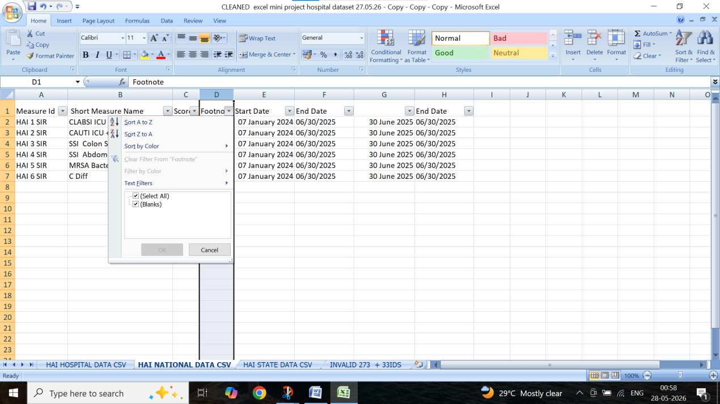

3.STATE DATA CSV
1.MEASURE ID CHANGED BY SUBSTITUTE FORMULA
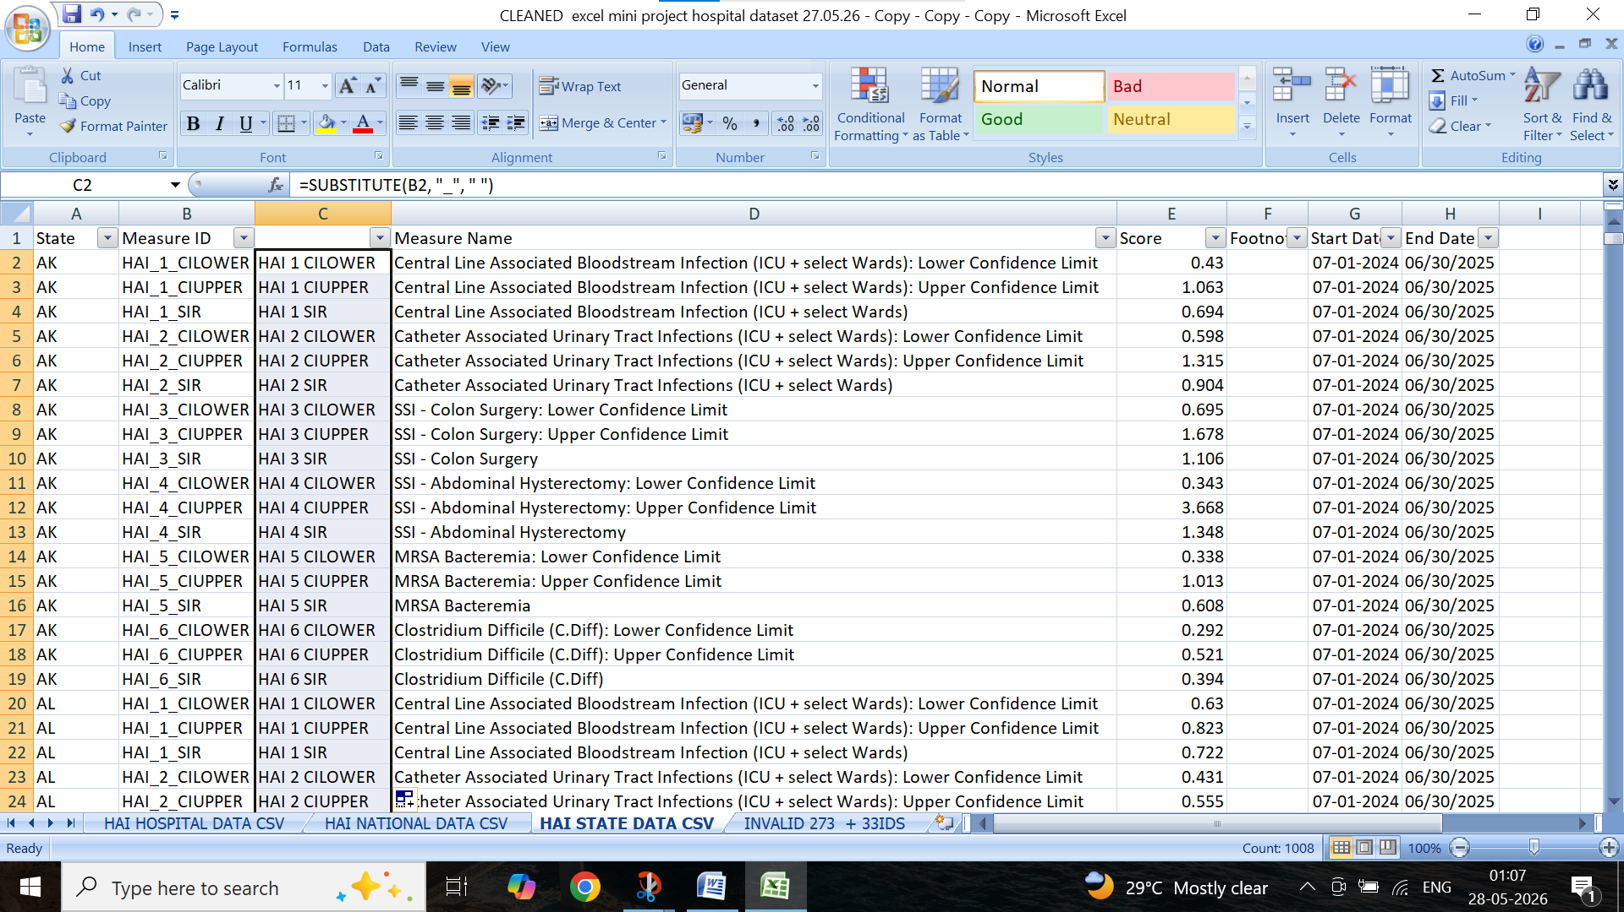

2. MEASURE NAME CHANGED BY FIND WHAT AND REPLACE WITH
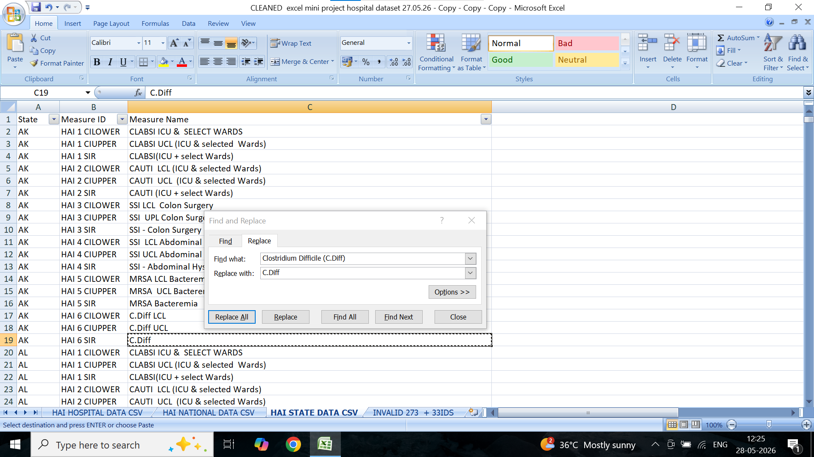

3.score cleaned with 0-2 range
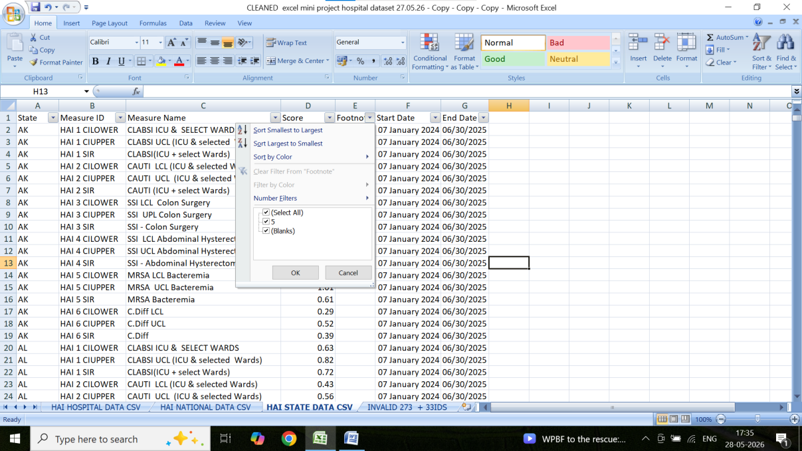

4.foot note cleaned with filter
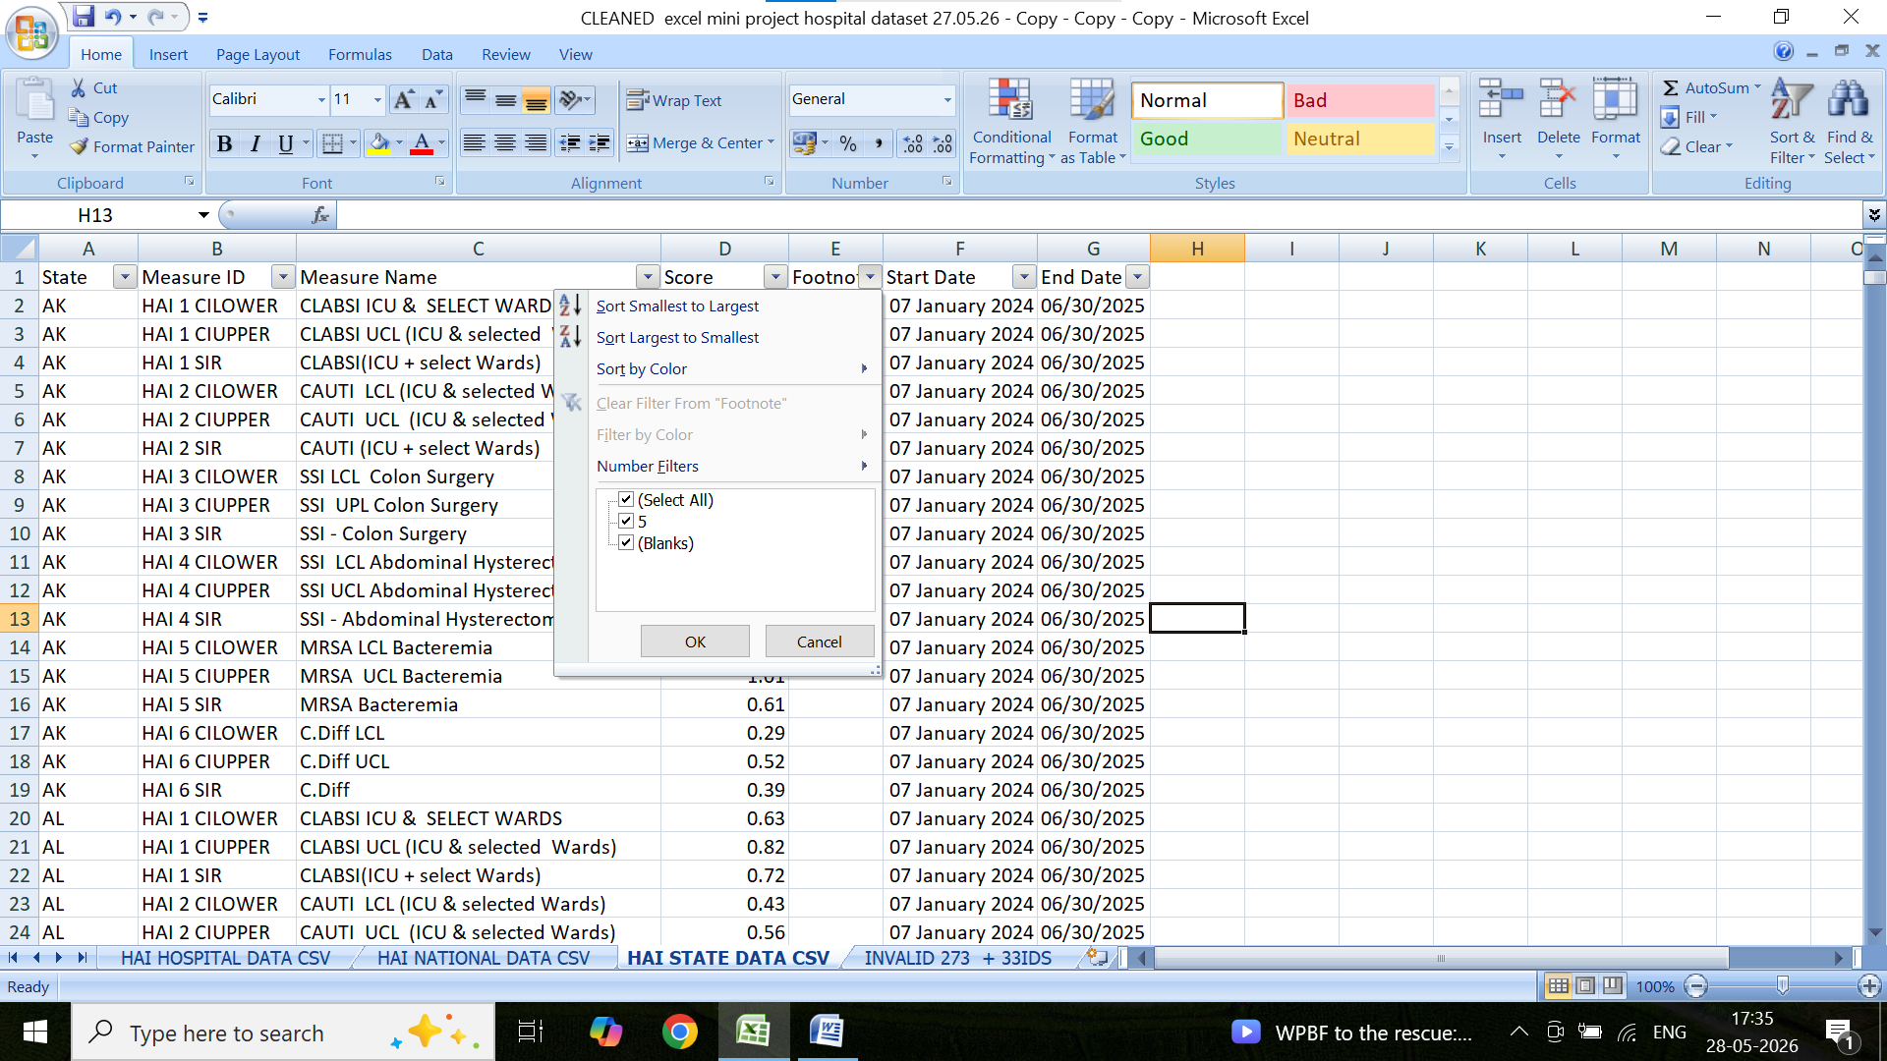
Start date changed by number then format cells to date
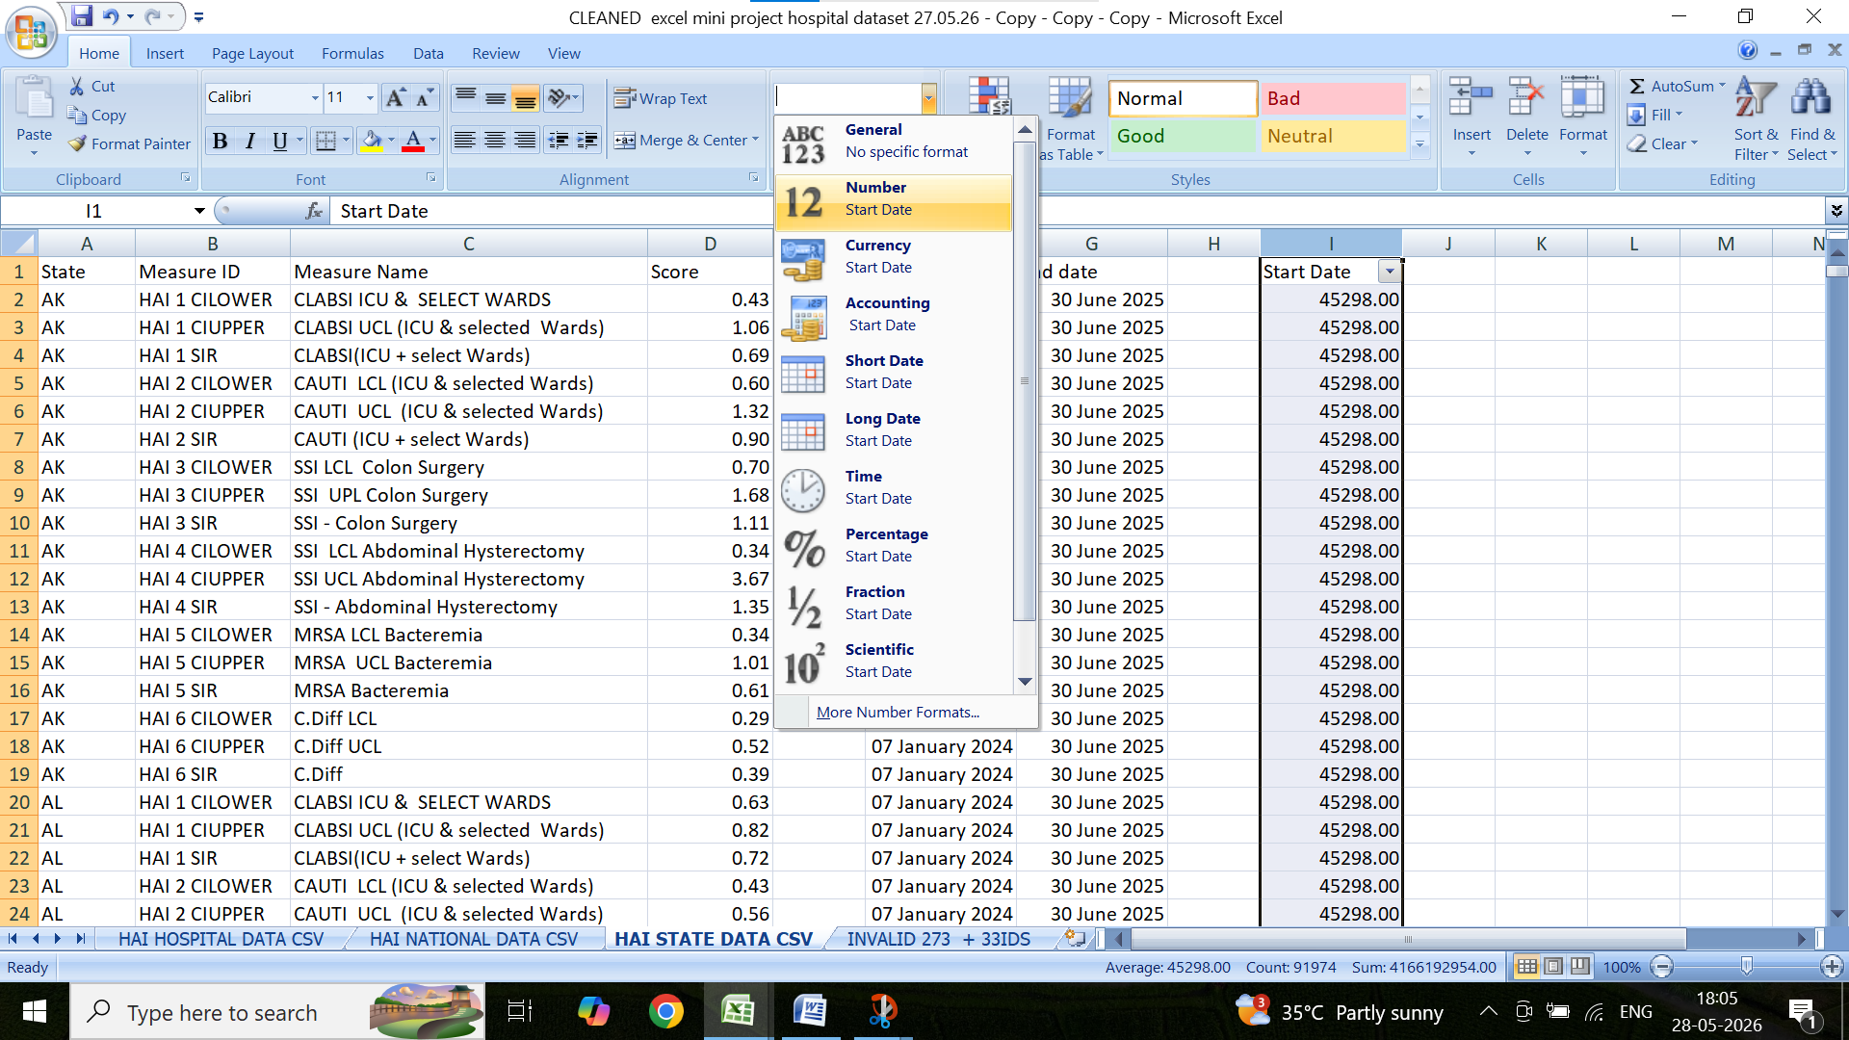
Start date changed second step 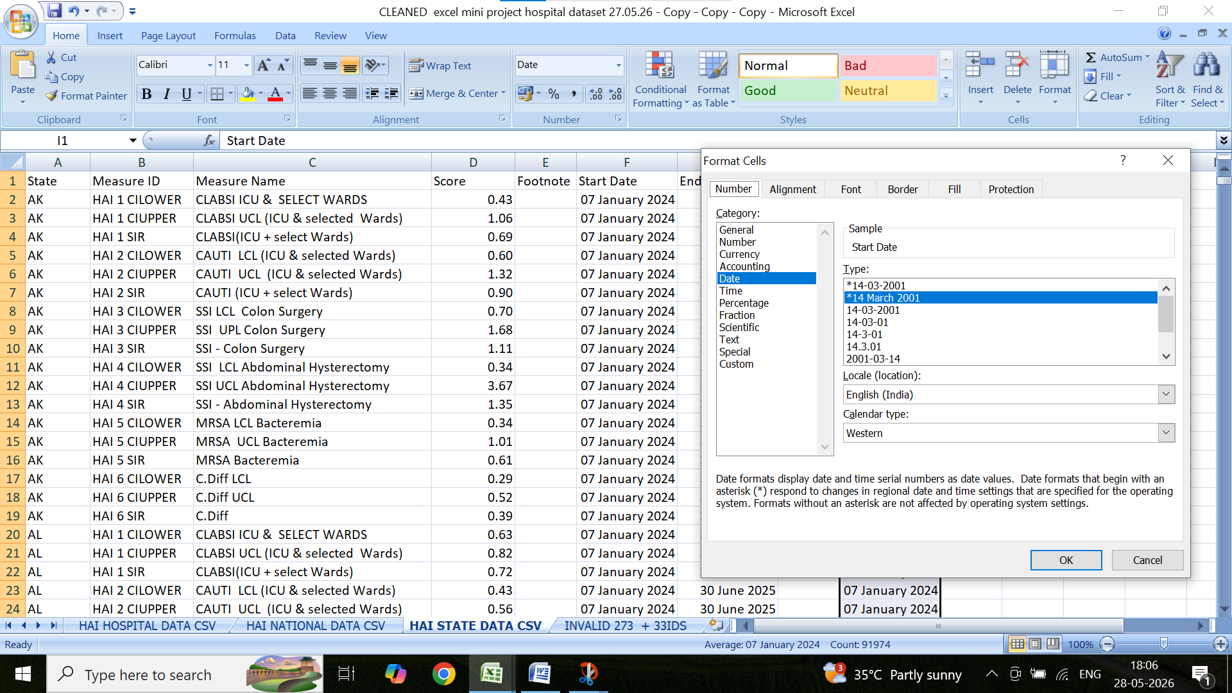

End date corrected by date right, left , mid fuctions
